Travelling Salesman Problem
AIM:
The shortest possible tour visiting every city once and returning to the starting city is found.

ALGORITHMS:
- Start.
- Initialize the starting node with cost $g(n)=0$.
- Calculate the evaluation function:
$$f(n)=g(n)+h(n)$$
where $g(n)$is the actual cost from the start node and $h(n)$is the estimated cost to the goal.
4. Insert the starting node into the open list.
5. Select the node with the lowest $f(n)$value.
6. If the selected node is the goal, display the path and total cost.
7. Otherwise, expand the node and calculate the costs of its neighboring nodes.
8. Update the costs and parent information of better paths, and add or update the neighbors in the open list. 9. Repeat steps 5–8 until the goal is reached or the open list becomes empty.
10. Stop.
CODE:

OUTPUT:
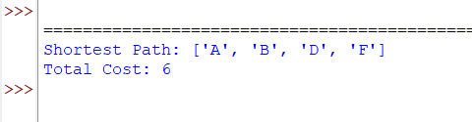

RESULT:
A Algorithm:\* The shortest path to the goal is found using the cost function and heuristic value.

